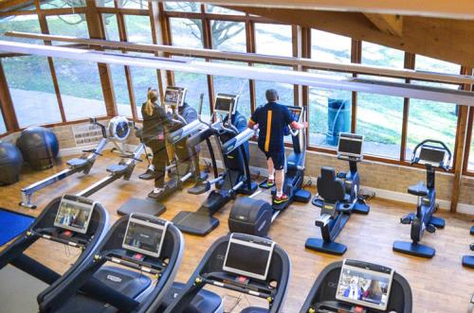
Gym Use
- All sessions must be booked in advance via phone or email. Max of 15 spaces per 60 mins booking.
- Members only. No guests at this time.
- Weekday sessions available are;
08.00-09.00 | 09.30-10.30 | 11.00-12.00 | 12.30-13.30 | 14.00-15.00 | 15.30-16.30 | 17.00-18.00 | 18.30-19.30 | 20.00-21.00
- Saturday sessions available are;
08.15-09.15 | 9.45-10.45 | 11.15-12.15 | 12.45-13.45 | 14.15-15.15 | 15.45-16.45
- Sunday sessions available are;
9.45-10.45 | 11.15-12.15 | 12.45-13.45 | 14.15-15.15 | 15.45-16.45
- Please arrive a maximum of 5 minutes before your booked session and sign in at reception.
- Please arrive dressed in gym gear. Dry changing room only available for toilet use.
- One-way system in sports centre and around gym. Please follow the signs.
- There will be 10 pieces of cardio equipment available and all suitably distanced from others.
- Most Resistance machines available and spaced out matted area.
- All free weights available in the back gym with platforms and bars. Experienced users access only.
- Members to wipe down each piece of equipment after use with blue roll and spray provided.
- No personal gym towels.
- Please do not bring any unnecessary bags, clothing or belongings.
- Please leave promptly at the end of your session.
- Windows open for fresh air ventilation.
- Use of water fountains to fill up wide rimmed bottles only. No mouth to tap use.
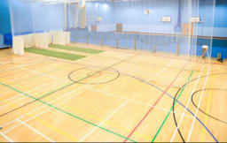
Sports Hall
- Pre-booked activities only via email or phone.
- All bookings to submit a register of participants to reception. Maximum 30 heads per booking.
- Arrival via the sports hall doors.
- A register of the names in each booking must be emailed or handed into reception.
- Participants not to bring unnecessary belongings.
- Use of dry changing is for toilets only. Maintain distancing whilst waiting.
- No spectators or use of balcony.
- No loitering in corridor.
- Exit via sports hall doors.
- Equipment on request only and must be wiped down before and after use with roll and spray provided.
- Badminton singles only or doubles with household members only.
- No competitive football or other contact sports.
- Coaching must be accompanied by a risk assessment.
- No vending machines available.

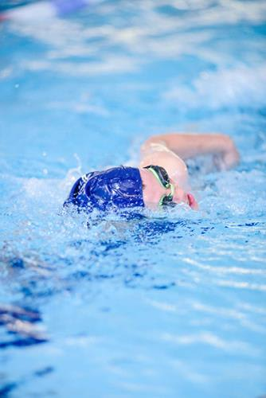
Swimming Pool
- All sessions must be booked in advance via phone or email. Max of 10 spaces per 60 mins booking.
- Members only. No guests at this time.
- Weekday sessions available are;
08.00-09.00 | 09.30-10.30 | 11.00-12.00 | 12.30-13.30 | 18.30-19.30 | 20.00-21.00
- Saturday sessions available are;
08.15-09.15 | 9.45-10.45 | 11.15-12.15 | 12.45-13.45
- Sunday sessions available are;
9.45-10.45 | 11.15-12.15 | 12.45-13.45
- Disabled swim available via email booking.
- Young children/family swim available via email booking.
- Please arrive a maximum of 5 minutes before your booked session. At reception you will be given a yellow band to wear during your swim which notifies the lifeguard that you have booked and are aware of the conditions of use. Please deposit the yellow band in the box in the changing room as you leave. These will then be washed/cleaned.
- Please come swim ready. Shower at home so that changing room use is kept short prior to swim.
- Max of 15 mins in changing room post swim.
- One way system in sports centre and around poolside.
- Shallow end is entry and deep end is exit (unless in special circumstances)
- Swimmers to swim in double lanes only and follow specific direction of that lane ie Clockwise/Anticlockwise.
- No overtaking. Slower swimmers to give way to faster swimmers at the end of the lane.
- No spectators permitted.

Reception and Booking Procedures
- Please book your sessions via phone 01202 847524 or email sportscentre@canford.com . We will endeavour to confirm your booking as quickly as we can however please be aware that it may take 24 hours to confirm your booking if reception is busy.

- Bookings will be available from Monday 20th July.

- Members can book up to 7 days in advance for any session/class. You can book no more than one of each of a swim, gym or class per day.

- As spaces on member swim and gym sessions are limited we ask that you notify us of cancellation if you do not intend to use the space.

- On entry to the sports centre please use the hand sanitiser provided and join the queue if there is one. There will be markings on the floor to maintain social distance in queues as per many shops, supermarkets etc.

- There will be a barrier in front of our reception at a 1m plus distance away from the desk. Any payments must be by card. No cash accepted.

- At reception all you will need to do is give your name and you will then be allowed entry. If you are booked for the swim then you will also be able to collect a yellow band. You will not be able to book a further session here, this must be done via phone or email as we will then be able to get through the queue quickly.

- When you wish to restart your membership, please email us and we will action for you. If a new standing order form is required you will be given an appointment time before your session to come and complete the relevant paper work.

- Please follow the one way systems in place around the centre.

- PLEASE NOTE WE ARE WORKING TOWARDS THE INTRODUCTION OF AN ONLINE BOOKING APP BUT THE MEANTIME PLEASE BE PATIENT WITH OUR STAFF WHO WILL TRY AND HELP YOU AS QUICKLY AS WE CAN.

Group Fitness Classes – These will be introduced gradually through August. There will be a new programme for the week commencing the 3rd August which will be released soon. The classes will have a maximum of 10 in each and each participant will be spaced away from another. Where possible we will run as many of the classes outside on Canford’s picturesque grounds. There will be limited or no equipment in use and we ask members to bring their own mats if they have them. Due to limited space the sessions will only be available for members of the centre and all sessions must be booked in advance. Once we understand demand we will then be able to invite non-members to book.

Memberships – We welcome you to restart your membership anytime from July 25th. To do so please email sportscentre@canford.com and we will then confirm your new renewal date based on the time that you had not been able to use the centre. Due to the new conditions of the centre in Phase 1 we understand that you may not be ready to or want to return, so we will continue to freeze your memberships until the end of October and continue to add on any time that you may have missed onto your renewal date. We very much hope that we can return to more normal operations in the autumn but are also aware that there may be some adjustments for the school when the pupils return. Phase 2 of reopening will be confirmed towards the end of August as guidance changes and the school has more information.

Block Bookings – If your booking in the sports hall cannot restart at this stage due to restrictions on contact, distancing or guidance on certain sports then we will continue to honour your block booking for when you can restart. We will only sell sports hall space for the interim whilst you are not here. Please be aware that due to the school returning in September there may be some restrictions on space that are out of our control but where possible we will endeavour to accommodate our block bookings. If there are any changes to our availability we will let you know at the earliest opportunity.

Cleaning – We can assure you that the Sports Centre has been thoroughly deep cleaned and made safe for your return. Sessions and bookings have been limited to allow continued cleaning of all facilities as well as limit the number of people in the building at anyone time to reduce the risk of transmission. Contact points will be regularly wiped with disinfectant between each session. Daily cleaning procedures have been increased to ensure that you are coming into a safe environment.

Your Visit – We ask that all users of the sports centre respect the guidelines that are in place and follow the advice of staff. We cannot operate the sports centre at this time without your support. You may be asked to leave if you are not co-operating with the guidelines or ignoring staff instructions which are there to keep both members and staff safe. Please ensure that you do not visit the sports centre if you feel at all unwell.

Further details of control measures are noted in our dryside and wetside risk assessments which will be on display in the sports centre.

Phase 2 – As referred to in the memberships section, please be aware that ‘Phase 2’ of reopening will be from September 1st. As government guidance and school plans are confirmed over the next few weeks we will need to adjust the operation and availability of facilities. Of course, we hope this will be in a positive way allowing us to return to normal operations however we are mindful that new restrictions may be put in place and/or the needs of the school may change which may affect operations.

We will continue to keep members and bookings updated.

We look forward to seeing you back in the centre soon.

Best Wishes,

Canford Sports Centre

